Design outline:

My plan for the program was to have a loop that requests a password from the user until a valid password is entered. The program will decide whether the password was valid from 3 separate functions, one for checking the password length is proper, another to check for illegal characters, and a third for checking that the password has numbers and characters. If any of the functions evaluates the password to be invalid it will print to the user specifically what was incorrect so they can have a better next opportunity to input a new password.

Test plan:

1: I will test my program’s ability to re request a new password from the user if a password is invalid

2: I will test that my functions correctly report when the password is invalid

3: I will test that my program accepts a password that passes all of the requirements.

test 1:  
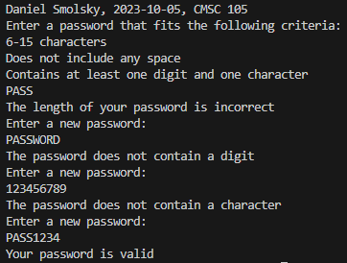

test 2:  
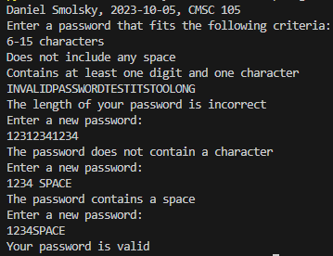

test 3:  
